# Exercises: XML Processing

# Car Dealer Database

A car dealer needs information about cars, their parts, parts suppliers, customers and sales.

* **Cars** have **make, model**, **and travelled distance** in kilometers.
* **Parts** have **name**, **price** and **quantity**.
* Part **supplier** have **name** and info whether he **uses imported parts**.
* **Customer** has **name**, **date of birth** and info whether he/she **is a young driver** (Young driver is a driver that has **less than 2 years of experience**. Those customers get **additional 5% off** for the sale.).
* **Sale** has **car**, **customer** and **discount percentage**.

A **price of a car** is formed by the **total price of its parts**.

Using Code First approach create a database following the above description.

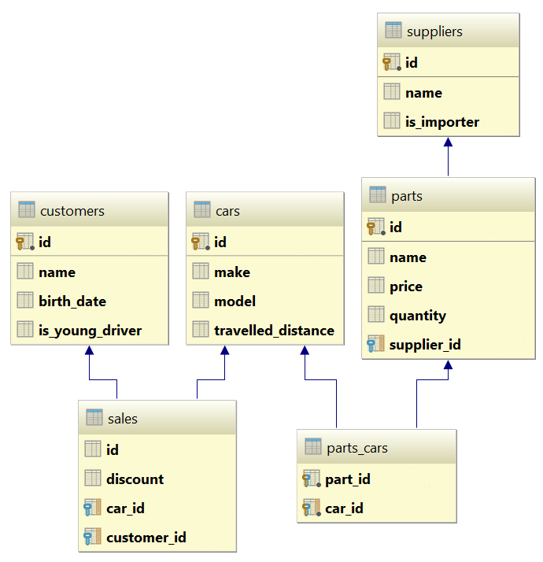

# Car Dealer Import Data

Import data from the provided files (**suppliers.xml, parts.xml, cars.xml, customers.xml**).

First import the **suppliers**. When importing the **parts** set to each part a **random supplier** from the already imported suppliers. Then, when importing the cars add **between 10 and 20 random parts** to each car. Then import **all customers**. Finally, import the **sales records** by **randomly** selecting a **car,** a **customer** and the amount of **discount to be applied** (discounts can be 0%, 5%, 10%, 15%, 20%, 30%, 40% or 50%).

## Car Dealer Query and Export Data

Write the below described queries and **export** the returned data to the specified **format**.

#### Query 1 – Ordered Customers

Get all **customers** ordered by their **birthdate in ascending order**. If two customers are born on the same date, **first print those, who are not young drivers** (e.g. print experienced drivers first). **Export** the list of customers **to XML** in the format provided below.

|  |
| --- |
| **ordered-customers.xml** |
| <?xml version="1.0" encoding="utf-8"?>  <customers>  <customer>  <id>29</id>  <name>Louann Holzworth</name>  <birth-date>1960-10-01T00:00:00</birth-date>  <is-youn-driver>false</is-young-driver>  </customer>  <customer>  <id>28</id>  <name>Donnetta Soliz</name>  <birth-date>1963-10-01T00:00:00</birth-date>  <is-youn-driver>false</is-young-driver>  </customer>  ...  </customers> |

**Query 2 – Cars from Make Toyota**

Get all **cars** from make **Toyota** and **order them by model alphabetically** and by **travelled distance in descending order**. **Export** the list of **cars to XML** in the format provided below.

|  |
| --- |
| **toyota-cars.xml** |
| <?xml version="1.0" encoding="utf-8"?>  <cars>  <car id="117" make="Toyota" model="Camry Hybrid" travelled-distance="954775807" />  <car id="112" make="Toyota" model="Camry Hybrid" travelled-distance="92275807" />  ...  </cars> |

#### Query 3 – Local Suppliers

Get all **suppliers** that **do not import parts from abroad**. Get their **id**, **name** and **the number of parts they can offer to supply**. **Export** the list of suppliers **to XML** in the format provided below.

|  |
| --- |
| **local-suppliers.xml** |
| <?xml version="1.0" encoding="utf-8"?>  <suppliers>  <suplier id="2" name="Agway Inc." parts-count="6" />  <suplier id="4" name="Airgas, Inc." parts-count="5" />  ...  </suppliers> |

#### Query 4 – Cars with Their List of Parts

Get all **cars along with their list of parts**. For the **car** get only **make, model** and **travelled distance** and for the **parts** get only **name** and **price**. **Export** the list of **cars and their parts to XML** in the format provided below.

|  |
| --- |
| **cars-and-parts.xml** |
| <?xml version="1.0" encoding="utf-8"?>  <cars>  <car make="Opel" model="Omega" travelled-distance="2147483647" />  <parts>  <part name="Front Left Side Outer door handle" price="999.99" />  <part name="Gudgeon pin" price="44.99" />  <part name="Oil pump" price="100.19" />  <part name="Transmission pan" price="106.99" />  </parts>  </car>  <car make="Opel" model="Astra" travelled-distance="9223372036854775807" />  <parts>  <part name="Overflow tank" price="1200.99" />  ...  </parts>  </car>  ...  </cars> |

#### Query 5 – Total Sales by Customer

Get all **customers** that have bought **at least 1 car** and get their **names**, **count of cars bought** and **total money spent** on cars. **Order** the result **by total money spent in descending order** and then by **total amount of cars bought** again in **descending** order. **Export** the list of customers **to** **XML** in the format provided below.

|  |
| --- |
| **customers-total-sales.xml** |
| <?xml version="1.0" encoding="utf-8"?>  <customers>  <customer full-name="Hipolito Lamoreaux" bought-cars="5" spent-money="8360.48" />  <customer full-name="Francis Mckim" bought-cars="4" spent-money="7115.50" />  <customer full-name="Johnette Derryberry" bought-cars="4" spent-money="5337.72" />  ...  </customer> |

#### Query 6 – Sales with Applied Discount

Get all **sales** with information about the **car**, the **customer** and the **price** of the sale **with and without discount**. **Export** the list of sales **to XML** in the format provided below.

|  |
| --- |
| **sales-discounts.xml** |
| <?xml version="1.0" encoding="utf-8"?>  <sales>  <sale>  <car make="Peugeot" model="405" travelled-distance="92036854775807" />  <customer-name>Donnetta Soliz</customer-name>  <discount>0.3</discount>  <price>1402.53</price>  <price-with-discount>981.771</price-with-discount>  </sale>  <sale>  <car make="Mercedes" model="W124" travelled-distance="2147647" />  <customer-name>Carri Knapik</customer-name>  <discount>0.2</discount>  <price>254.96999999999997</price>  <price-with-discount>203.97599999999997</price-with-discount>  </sale>  ...  </sales> |